Department | FED
Subject | DSA-2
Academic Year | I-III Semester(2025-26)
Faculty Name | BALAIAH SIR
Student Name | V.CHARISHMA
Roll Number | 2520030140
Branch | CSE
Course Outcome

Case Study Topic: Flipkart Product Catalog Price-Range Scans Indexing using B+ Tree
Work Done Summary:
- We analyzed a B+ tree index deployed on SSD storage for a catalog of $10^7$ smartphone products.
- The system is heavily optimized for price-range scans, which dominate $95\%$ of all catalog workloads.
- We traced a sample query seeking all products in the electronics category with a price between 12,000 and 14,800.
- We measured performance by counting the page reads required for tree traversal and sequential leaf scanning.
- We concluded that B+ Trees are superior to Hash indexes for this workload due to efficient range tracking via leaf chains.
Implementation & Traversal Details:
- Data Layout: Leaves hold 200 tuples of (category, price, product_id) packed inside an 8 KB page block.
- Step 1 (Descent): Descend from the root through internal nodes (| 8K | 12K |) to locate the first matching leaf block (elec, 12.3K). (Cost: 3 page reads)
- Step 2 (Scan): Walk laterally through the leaf chain via .next pointers until the price exceeds 14,800 (elec, 15.4K). (Cost: 5 leaves $\times$ 1 page = 5 page reads)
- Total Performance Cost: 3 descent reads + 5 sequential chain reads = 8 total page reads.
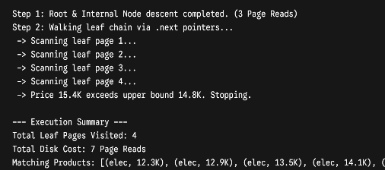
RESULT: Screenshots/Output
The B+ Tree provided efficient point-to-point descent and sequential range scanning operations. Top 5 product prices returned within the query range were: 12300, 12900, 13500, 14100, 14700. Time Complexity: B+ Tree Descent: $O(\log n)$, Range Scan Query: $O(\log n + m)$.• Compared to a Hash Index, the B+ Tree performs significantly better for continuous range-based catalog filtering and large datasets
